U Query V Answer

Project increment 3

Submitted by

Arimanda,Syamala Reddy

Boyanapalli,Swathi

Vakalapudi,Vinod Kumar

Katib,Rayan Faruq

**Introduction:**

Preparation is an important task and plays a key role for the students in the case of selecting the universities. To qualify the gre and toefl exams, you need to know each and every detail about the exam, logon to their websites and surf about them. Also, it will be difficult to adapt to different patterns and designs as each website has their own in built design. To avoid these problems, our project acts as a single stop where in user can find different websites in one place with a common user interface (UI). This project provides feasibility to have sample exams and model papers all in a single application both through mobile and web applications.

**Overall goal:**

Our project gives clear idea about many things that are necessary for a student at the time of choosing a school to pursue his degree and also after attending the school. We have many features in our project which provides many answers to various types of questions that were really necessary and helpful to the students at the selection process of a school. We divide various questions into some groups.

Example: Admission Procedure is a group in which it can answer many questions like

1. What are the steps to be followed to apply to the school?

Ans: student should have gre, toefl/ ielts score card, transcripts, sop, lor etc.

2. What are the required scores that are mandatory to apply?

Ans: gre 300+ particularly having quant score more than 160 and Toefl with a score of 100 minimum or ielts with minimum of 6.5

3. Is the school accepts ielts score less than 6.5?

Ans: Yes, the school will also accepts the score of 6 but student must have to attend a test i.e., ALI.

Once the student decides his school then he will be provided with model test papers of both the gre and toefl/ ielts exams with all the sections covered in it.

Example: We provide sections like quant, verbal, analytical writing under gre exam and sections like speaking, listening, writing and reading under toefl exam.

**Proposed System:**

**Functional Requirements (Prioritized):**

* Students can register with their details, login and then update their profile if required.
* Students can choose the required exam and under that the required category in the website.
* Navigation and route maps are provided to the students about the universities.
* Statistics are provided to the students at different categories of exams like gre and toefl.

**Functional Requirements:**

* Our online service will be student friendly and easy to use.
* available on every day i.e., 24*7
* Loading our web application is fast as it uses very less bandwidth.

**System Architecture Diagram:**

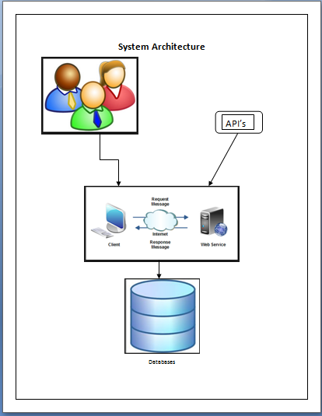

**Use Case Diagram:**

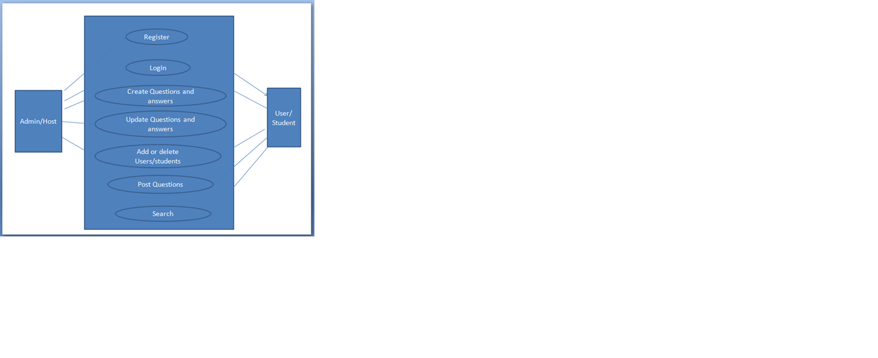

Screenshots:

Home Page:

This is our home page where we have icons for gre, toefl and the list of universities and we have one more service as contact us page as shown below.

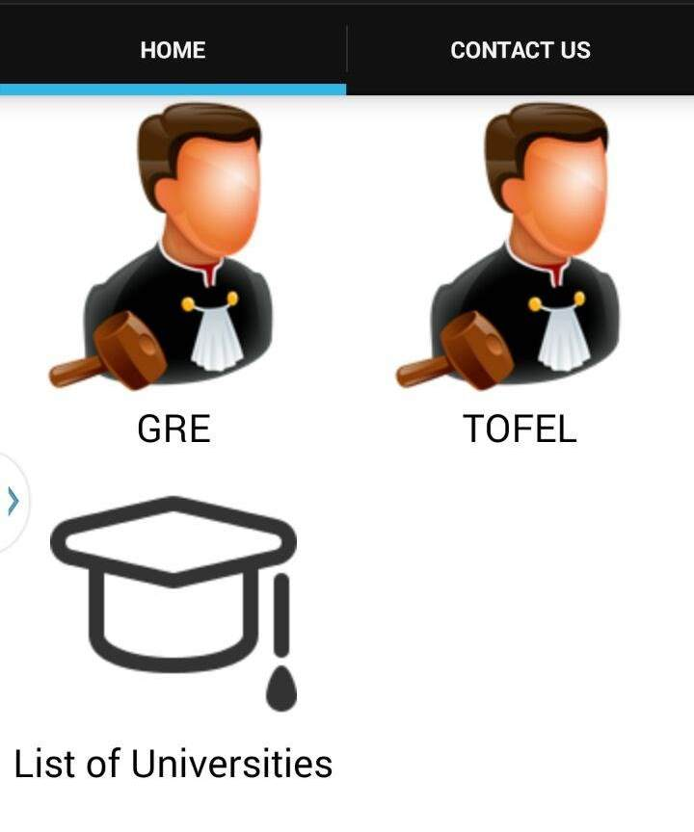

When the user clicks the gre icon it redirects to a page where all the information regarding gre is given.

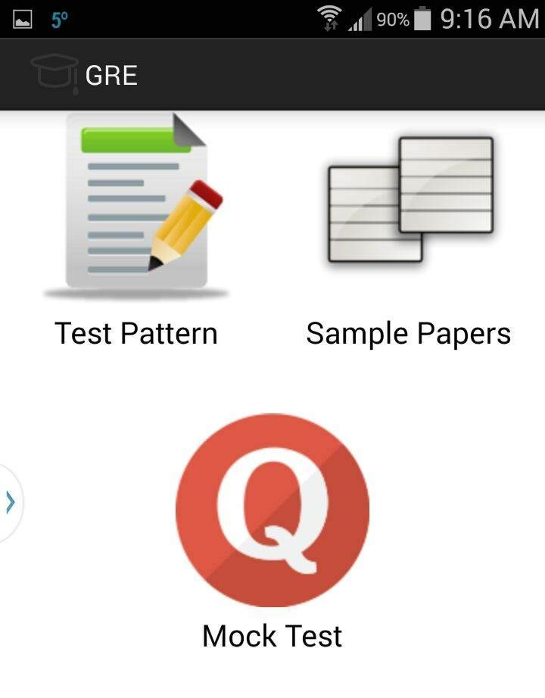

The above screenshot shows the icons like test pattern, sample papers and mock test where the test pattern gives the clear idea about the pattern of the test, sample pattern gives some example questions or problems from the test and the users are provided with the model papers too.

GRE Test Pattern:

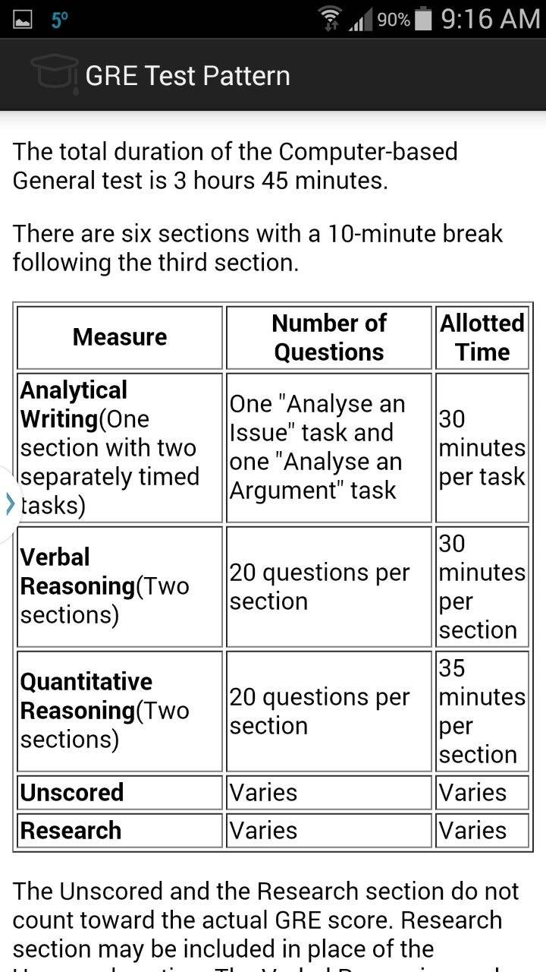

The above screenshot generally gives the description about the pattern of the exam say it gives the details about the sections in the exam even with time allotted for particular section and the weightage of the questions and all.

Sample Papers:

The below screenshot shows the sample papers icon with verbal reasoning, quantitative analysis and analytical writing.

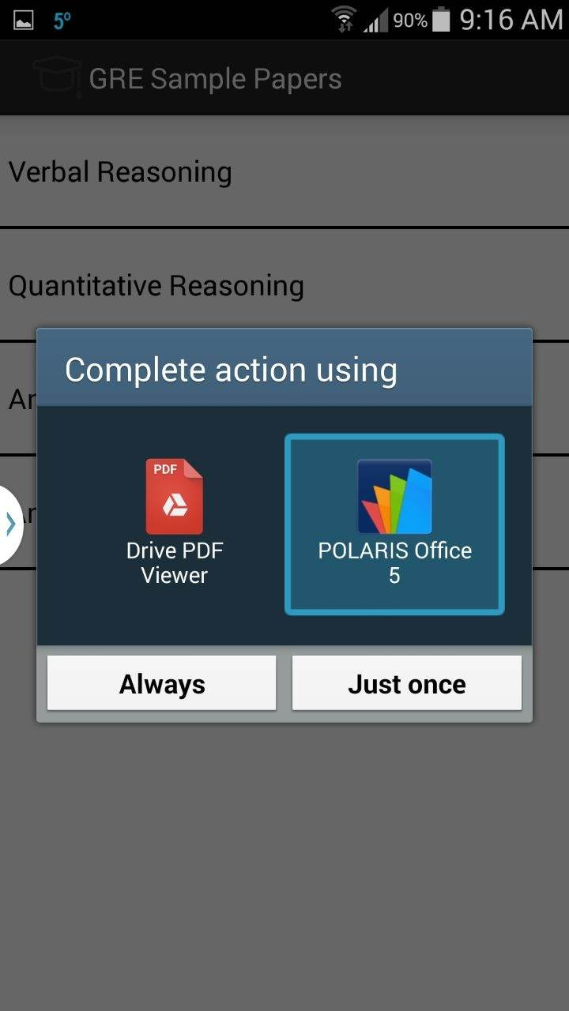

The below shown screenshot gives the sample model paper.

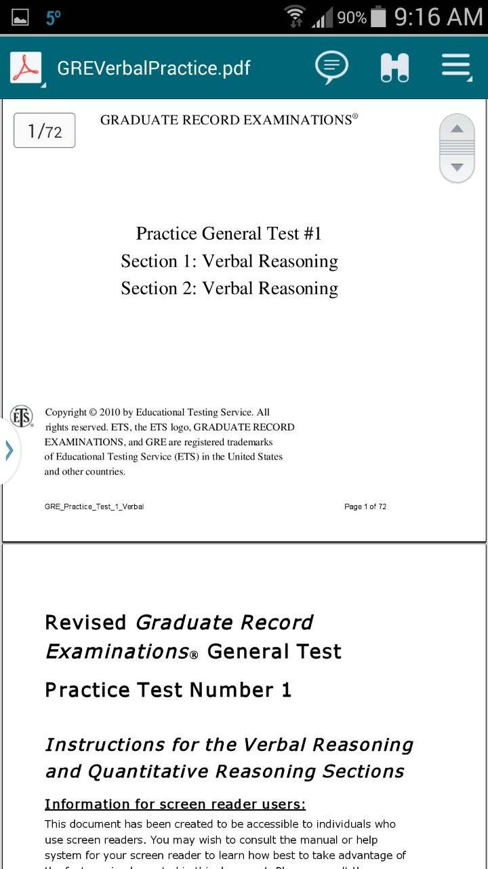

Mock Test:

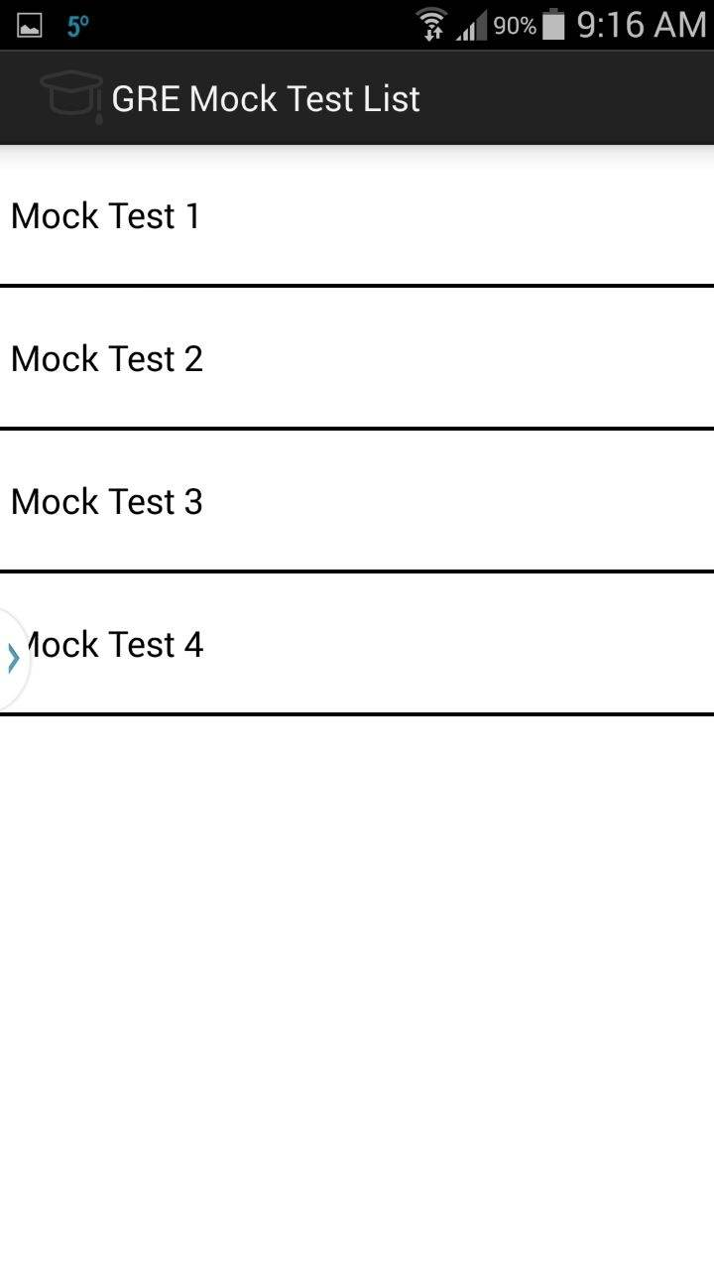

This shows the number of mock tests available in our application where users can have the sample test free of cost and can improve their skills. So when the user clicks the mock test then he is redirected to the corresponding test paper.

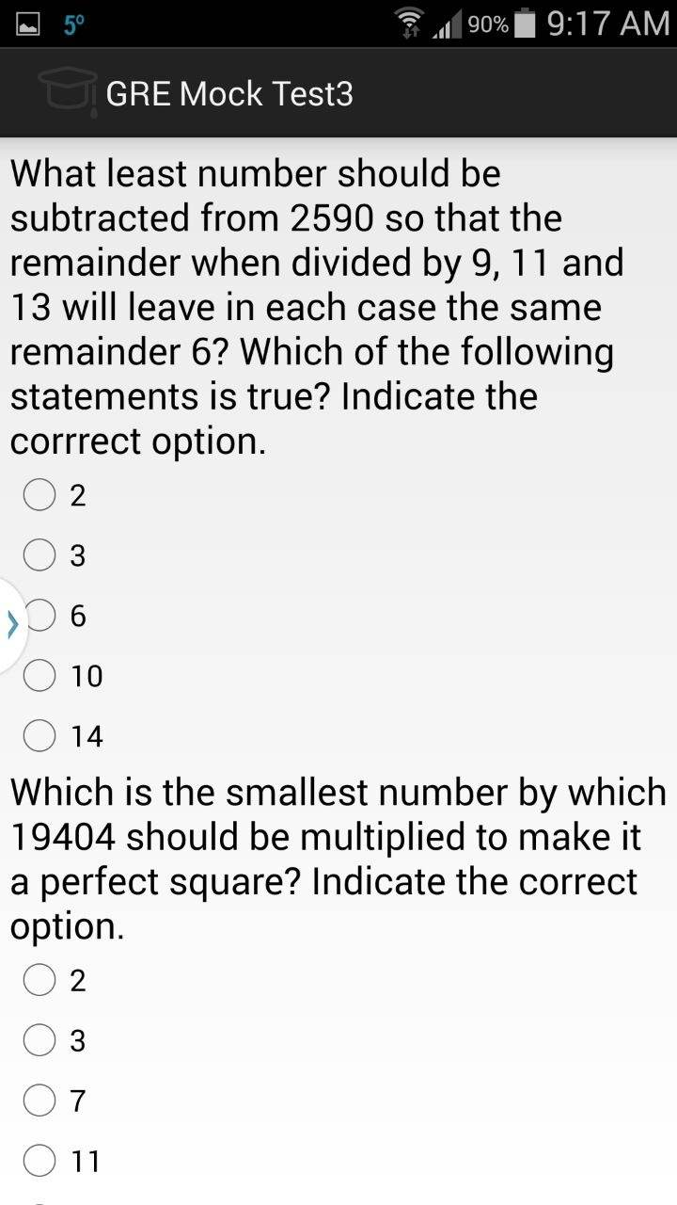

TOEFL:

The below screenshot shows the icons like test pattern, sample papers and mock test where the test pattern gives the clear idea about the pattern of the test, sample pattern gives some example questions or problems from the test and the users are provided with the model papers too.

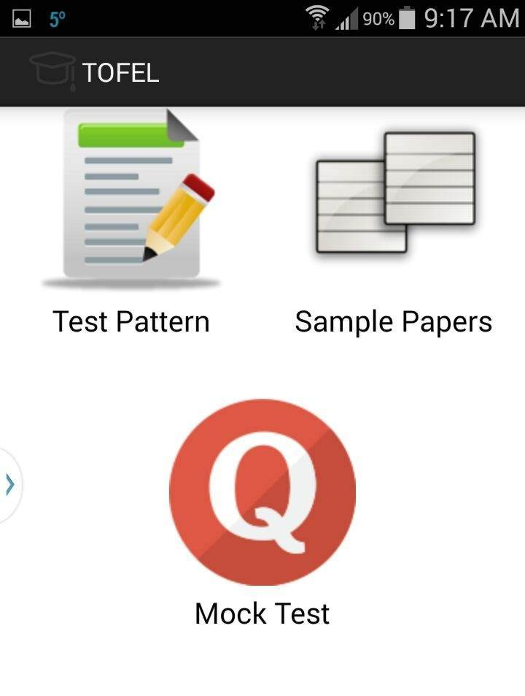

Test Pattern:

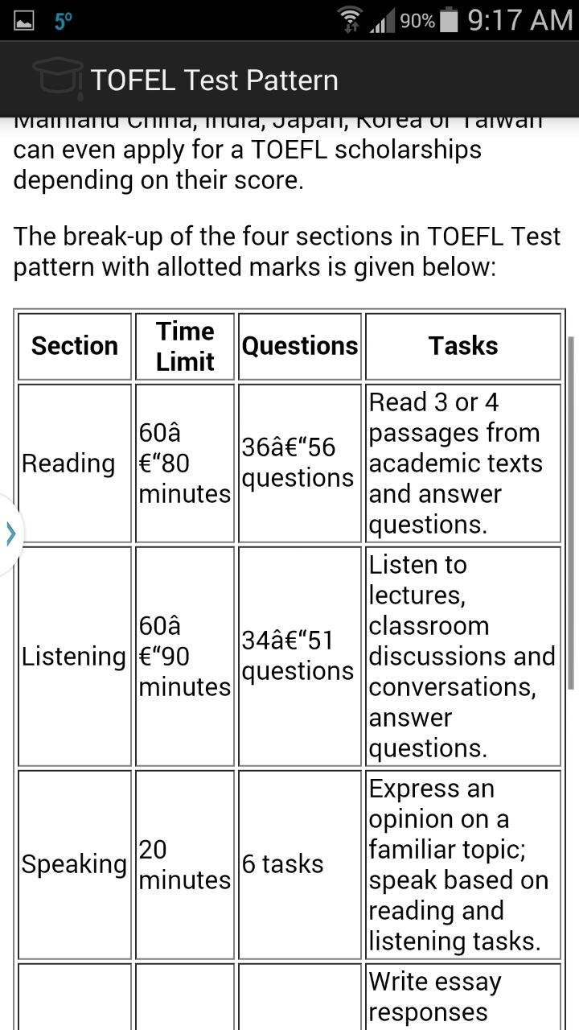

The above shown screenshot gives clear idea about the test pattern with the sections like reading, speaking, listening and writing and detailed idea about the tasks to be done under each section with the number of questions and the time allocated for each section.

Sample papers:

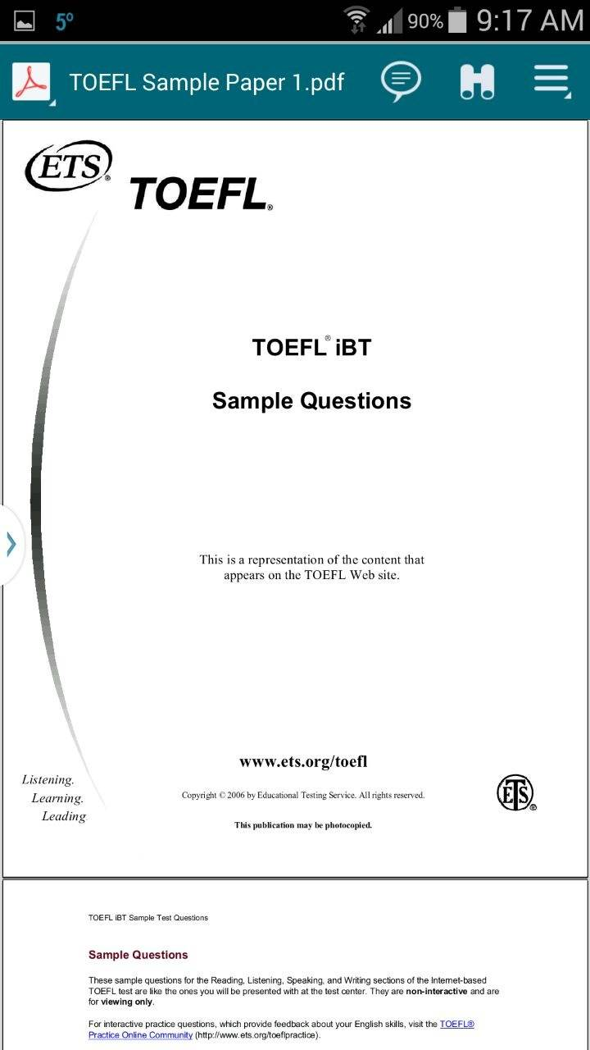

Above shown is the screenshot of sample paper.

Mock test:

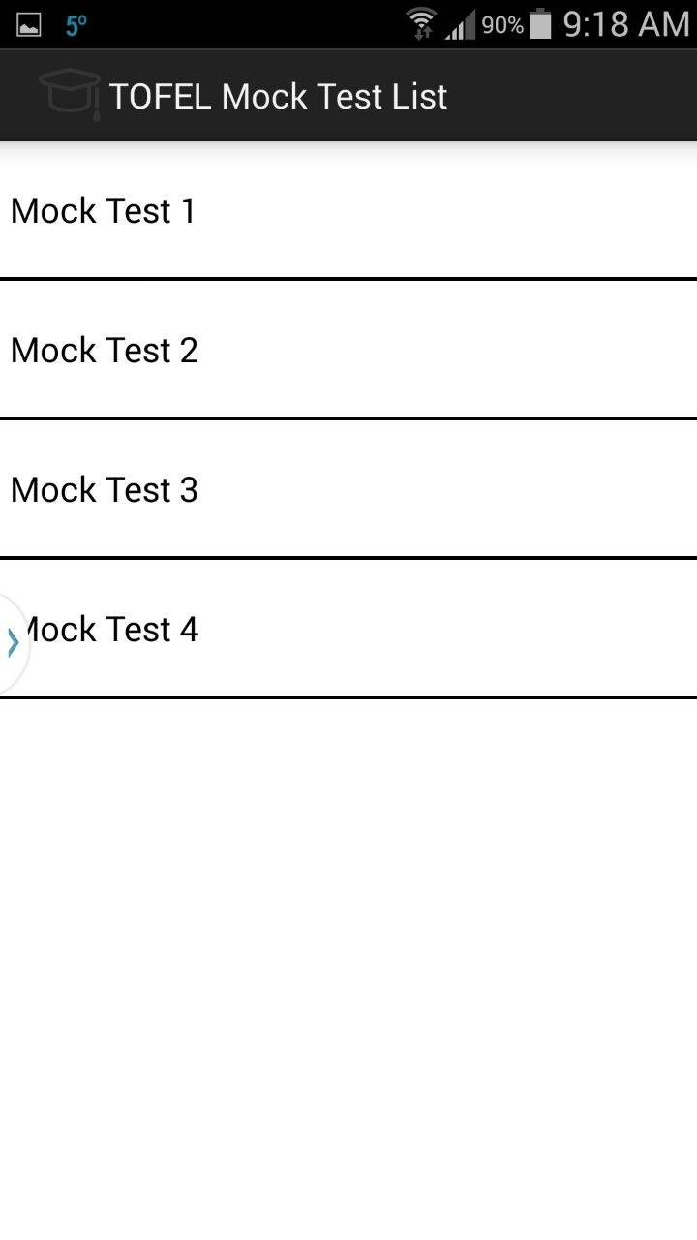

The above shown screen shot shows the number of model papers where users can view and practice all the sample mock test and enhance their skills and can assess their capability in each and every section.

Universities:

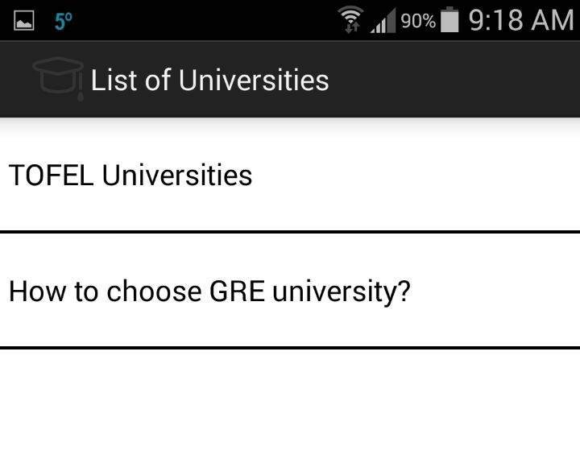

Accessing the score from the model test papers he may calculate the corresponding scores and can have an idea of the university depending upon his credentials and can even aim for the universities of his choice by improving the performance in each section.

Universities based on gre score:

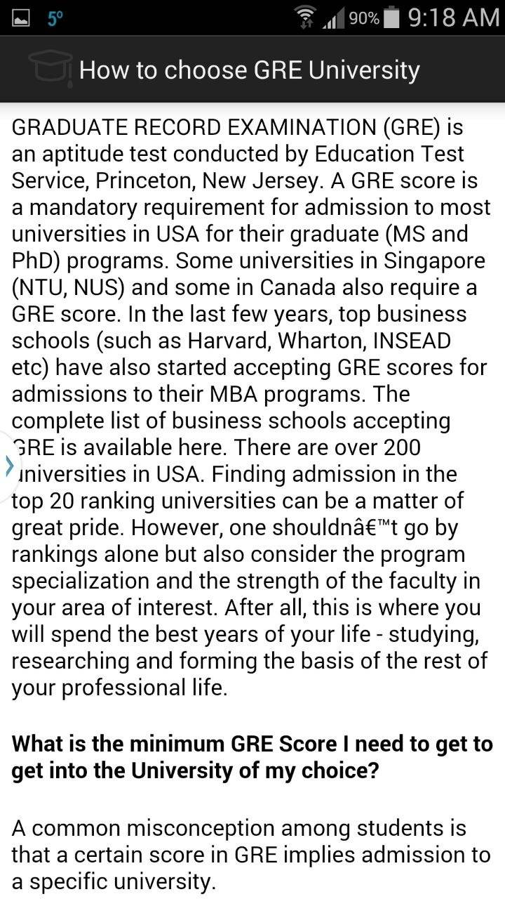

The above screenshot shows the information about the universities and the list of universities depending on the score obtained in the mock tests student may asses their universities and may apply for them.

Universities based on Toefl score:

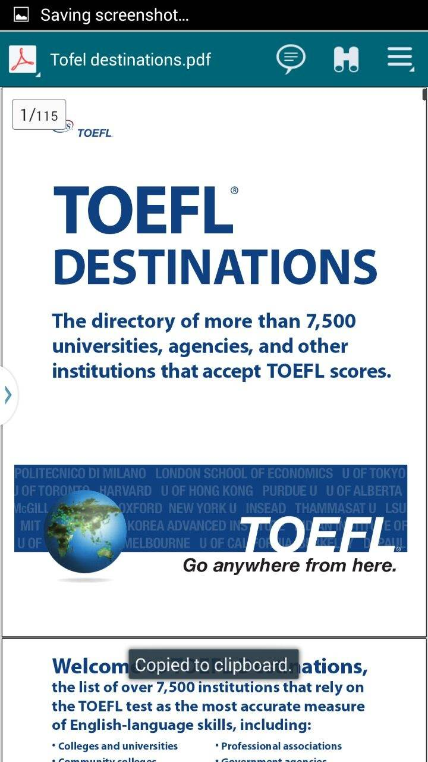

The above shown screenshot gives clear idea about the list of universities based on the Toefl score so that the user can have clear idea about the score requirements of the particular university.

Contact Us:

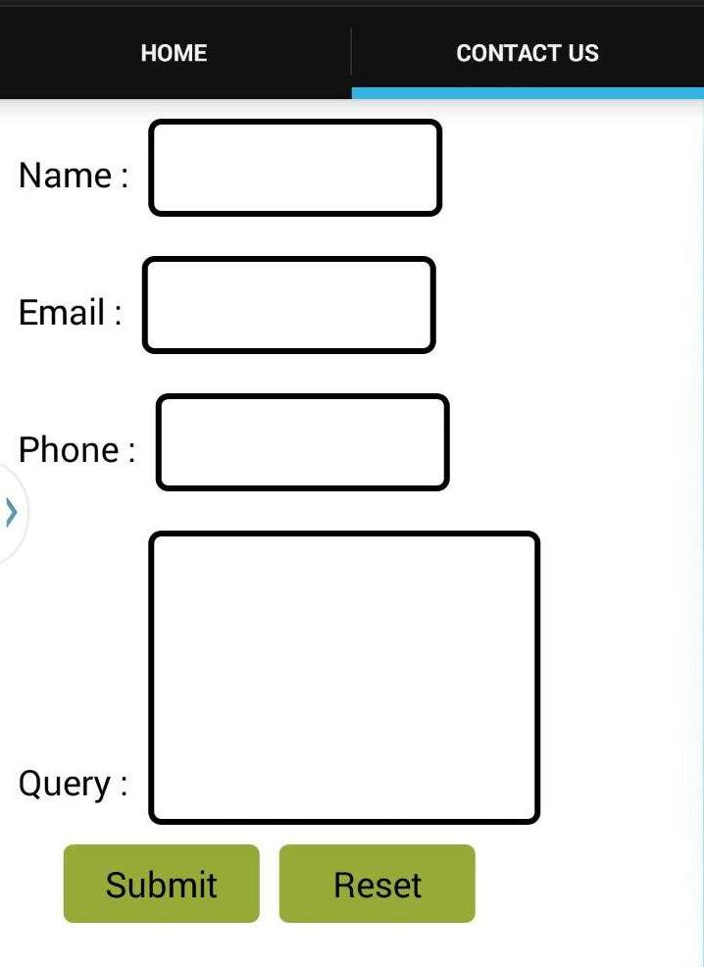

The above screenshot shows the contact us page where the user can have his query sent to us by giving some normal details like name, email and phone number and clicks the submit button.

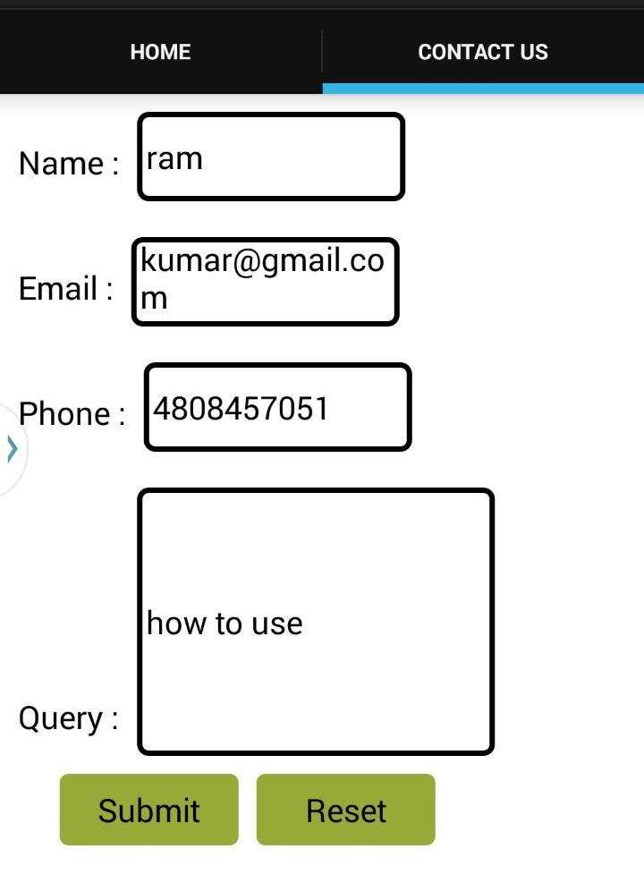

The above shown screenshot is the example of the contact form and gives clear idea about this service.

Roles and Responsibilities:

|  |  |  |
| --- | --- | --- |
| **Sl.No** | **Task** | **Person involved** |
| 1. | Android web pages are designed | Syamala  Vinod  Swathi |
| 2. | Further enhancements to second increment will be implemented. | Vinod  Rayan |
| 3. | Logo images to be inserted to each and every admin. | Rayan |
| 4. | Testing | Swathi  Syamala |
| 5. | Documentation | Syamala  Vinod  Swathi  Rayan |